Ojo echo $(pwd)

pwd

ls

docker run -d -p 8080:80 --name mi-contenedor httpd

Esto descarga la imagen httpd y crea un contenedor llamado mi-contenedor .

- Listar Contenedores: docker ps

- Detener un Contenedor: docker stop mi-contenedor

- Reiniciar un Contenedor: docker start mi-contenedor

- Eliminar un Contenedor: docker rm mi-contenedor

- Trabajar con Imágenes Docker:

- Descargar una imagen: docker pull nginx

- Listar imágenes: docker images

Parte 2:

- Dockerfile, Construcción y Registro

- Crear el directorio del proyecto En tu terminal, crea un nuevo directorio para tu proyecto y navega a él:
mkdir firstlab
cd firstlab

- Inicializar nuevo proyecto Node.JS Inicializa el proyecto con NPM para crear un package.json npm init -y

Parte 3:

- Crea el archivo de la aplicación NodeJS Crea un archivo llamado index.js con el siguiente contenido:
const express = require('express');
const app = express();
const PORT = process.env.PORT || 3000;

app.get('/', (req, res) => {
res.send('Hola Mundo');
});

app.listen(PORT, () => {
console.log(`Servidor corriendo en el puerto ${PORT}`);
});

1. Agregar Express como dependencia Añade Express, un framework de servidor web para NodeJS:
npm install express --save
2. Crear un Dockerfile para una Aplicación Node.js: Escribe un Dockerfile básico para una
aplicación Node.js.

FROM node:latest
WORKDIR /usr/src/app
COPY package*.json
./ RUNstall COPY .
. EXPOSE 3000
CMD ["node", "index.js"]

    - Construir la Imagen:

docker build -t mi-node-app .

docker run -d -p 3000:3000 mi-node-app

    - Crea una cuenta Docker Hub Crea una cuenta usando tu correo personal en Docker Hub

    - Registrar en Docker Hub: Inicia sesión en Docker Hub:
docker login Etiqueta tu imagen: docker tag mi-node-app [TU USUARIO DOCKERHUB]/mi-node-app Sube la imagen: docker push [TU USUARIO DOCKERHUB]/mi-node-app 10.

4.Descargar y Ejecutar la Imagen desde Docker Hub: docker run -d -p 3000:3000 [TU USUARIO DOCKERHUB]/mi-node-app

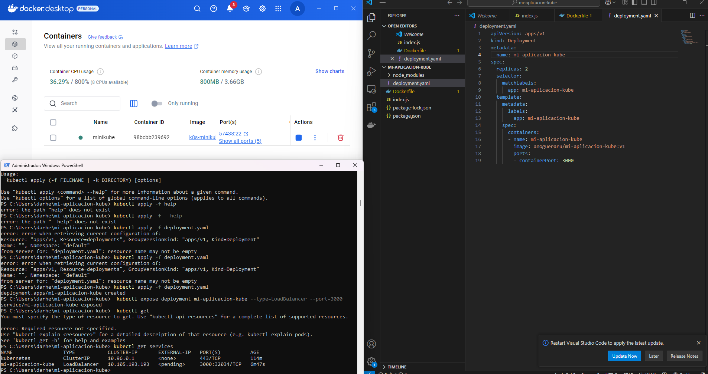

Id CommandLine
-- -----------
1 $oldPath = [Environment]::GetEnvironmentVariable('Path', [EnvironmentVariableTarget]::Machine)
2 if ($oldPath.Split(';') -inotcontains 'C:\minikube'){...
3 minikube start
4 kubectl get po -A
5 SanraMarta*+3105
6 dir
7 cd..
8 cd
9 cd..
10 cd Users
11 cd darhe
12 cd .\mi-aplicacion-kube
13 dir
14 kubectl apply -f deployment.yaml
15 cd..
16 cd..
17 cd..
18 minikube kubectl -- get po -A
19 alias kubectl="minikube kubectl --"
20 cd Users
21 cd darhe
22 cd .\mi-aplicacion-kube\
23 kubectl apply -f deployment.yaml
24 kubectl help
25 kubectl apply help
26 kubectl apply --help
27 kubectl apply -f help
28 kubectl apply -f --help
29 kubectl apply -f deployment.yaml
30 kubectl apply -f deployment.yaml
31 kubectl apply -f deployment.yaml
32 kubectl expose deployment mi-aplicacion-kube --type=LoadBalancer --port=3000
33 kubectl get
34 kubectl get services

Id CommandLine
-- -----------
1 $oldPath = [Environment]::GetEnvironmentVariable('Path', [EnvironmentVariableTarget]::Machine)
2 if ($oldPath.Split(';') -inotcontains 'C:\minikube'){...
3 minikube start
4 kubectl get po -A
5 SanraMarta*+3105
6 dir
7 cd..
8 cd
9 cd..
10 cd Users
11 cd darhe
12 cd .\mi-aplicacion-kube
13 dir
14 kubectl apply -f deployment.yaml
15 cd..
16 cd..
17 cd..
18 minikube kubectl -- get po -A
19 alias kubectl="minikube kubectl --"
20 cd Users
21 cd darhe
22 cd .\mi-aplicacion-kube\
23 kubectl apply -f deployment.yaml
24 kubectl help
25 kubectl apply help
26 kubectl apply --help
27 kubectl apply -f help
28 kubectl apply -f --help
29 kubectl apply -f deployment.yaml
30 kubectl apply -f deployment.yaml
31 kubectl apply -f deployment.yaml
32 kubectl expose deployment mi-aplicacion-kube --type=LoadBalancer --port=3000
33 kubectl get
34 kubectl get services
35 history
36 cd..
37 nvm install 23.11.0
38 cd..
39 cd..
40 nvm install 23.11.0
41 cd Users
42 cd darhe
43 cd mi-aplicacion-kube
44 cd..
45 minikube service mi-aplicacion-kube --url
46 mkdir mi-aplicacion2
47 cd mi-aplicacion2
48 npm init -y
49 npm install express
50 docker build -t anogueraru/mi-aplicacion-node:v2
51 docker build -t anogueraru/mi-aplicacion-node:v2 .
52 docker push anogueraru/mi-aplicacion-node:v2
53 kubectl apply -f deployment.yaml
54 kubectl expose deployment mi-aplicacion-node --type=LoadBalancer --port=3000
55 kubectl get services
56 kubectl apply -f deployment.yaml
57 kubectl expose deployment mi-aplicacion-node --type=LoadBalancer --port=5000
58 kubectl expose deployment mi-aplicacion-node2 --type=LoadBalancer --port=5000
59 kubectl get services
60 docker build -t anogueraru/mi-aplicacion-node2:v1 .
61 docker push anogueraru/mi-aplicacion-node2:v1
62 kubectl apply -f deployment.yaml
63 kubectl apply -f deployment.yaml
64 kubectl apply -f deployment.yaml
65 kubectl apply -f deployment.yaml
66 kubectl apply -f deployment.yaml --validate=false
67 kubectl apply -f --validate=false deployment.yaml
68 kubectl apply -f--validate=false deployment.yaml
69 kubectl apply -h--validate=false deployment.yaml
70 kubectl apply -h-validate=false deployment.yaml
71 kubectl apply -help
72 kubectl apply --help
73 cd..
74 cd .\kubernetes\
75 mkdir mi-aplicacion
76 cd .\mi-aplicacion\
77 npm init -y
78 npm install express
79 docker build -t anogueraru/mi-aplicacion-node:v1
80 docker build -t anogueraru/mi-aplicacion-node:v1 .
81 docker push anogueraru/mi-aplicacion-node:v1
82 kubectl apply -f service.yaml
83 kubectl apply -f service.yaml
84 kubectl apply --help
85 kubectl apply -f service.yaml
86 kubectl apply -f service.yaml
87 minikube start
88 kubectl apply -f service.yaml
89 kubectl apply -f service.yaml
90 kubectl get services
91 kubectl get nodes -o wide
92 kubectl delete service mi-aplication-node
93 kubectl delete service mi-aplication-node
94 kubectl delete service mi-aplicacion-node
95 kubectl expose deployment mi-aplicacion-node --type=LoadBalancer --port=3000
96 kubectl apply -f deployment.yaml
97 kubectl expose deployment mi-aplicacion-node --type=LoadBalancer --port=3000
98 kubectl get service
99 delete service mi-aplicacion-node
100 kubectl delete service mi-aplicacion-node
101 kubectl apply -f deployment.yaml
102 kubectl get services
103 kubectl apply -f deployment.yaml
104 kubectl apply -f service.yaml
105 kubectl get services
106 kubectl delete service mi-aplicacion-node
107 kubectl get services
108 kubectl apply -f service.yaml
109 kubectl apply -f service.yaml
110 kubectl get services
111 kubectl delete service mi-aplicacion-node
112 kubectl get services
113 kubectl apply -f service.yaml
114 kubectl delete service mi-aplicacion-node
115 kubectl get services
116 kubectl apply -f deployment.yaml
117 kubectl apply -f service.yaml
118 kubectl get services
119 kubectl expose deployment mi-aplicacion-node --type=LoadBalancer --port=80
120 kubectl get services
121 kubectl delete service mi-aplicacion-node
122 kubectl apply -f service.yaml
123 kubectl expose deployment mi-aplicacion-node --type=LoadBalancer --port=80
124 kubectl delete service mi-aplicacion-node
125 kubectl get services
126 kubectl apply -f deployment.yaml
127 kubectl expose deployment mi-aplicacion-node --type=LoadBalancer --port=80
128 kubectl get services
129 kubectl delete service mi-aplicacion-node
130 kubectl get services
131 kubectl apply -f service.yaml
132 kubectl expose deployment mi-aplicacion-node --type=LoadBalancer --port=80
133 kubectl get services
134 kubectl get services
135 kubectl get services
136 kubectl get services
137 kubectl delete service mi-aplicacion-node
138 kubectl get services
139 kubectl apply -f service.yaml
140 kubectl get services
141 kubectl apply -f deployment.yaml
142 kubectl get services
143 kubectl apply -f deployment.yaml
144 kubectl expose deployment mi-aplicacion-node --type=LoadBalancer --port=80
145 kubectl get services
146 kubectl delete service mi-aplicacion-node
147 kubectl get services
148 kubectl get services
149 kubectl apply -f deployment.yaml
150 kubectl expose deployment mi-aplicacion-node --type=LoadBalancer --port=80
151 kubectl get services
152 kubectl get services
153 kubectl get services
154 kubectl apply -f service.yaml
155 kubectl get services
156 kubectl get services

